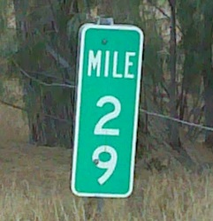

**MRCC “Milestone” Meeting**

Monday, February 29, 2016, 1:00 pm – 4:00 pm

Metro County Government Center, Room 205

2099 University Avenue, St Paul, MN 55104

**Meeting Agenda**

**1) Welcome, Intros, and Adjustments to the Agenda (if needed)**

**Acknowledgement of the Progress Made since May 2014**

**[MRCC Group/Houghton/Maas]*– 5 minutes***

**2) Brief Project Recap and Current Project Timeline and Purpose of Meeting, p. 2 - 3**

**[Houghton] *– 5 minutes***

**3) MRCC Data Standard Revisions, p. 4 - 15**

**[Group/Maas] *– 45 minutes***

**4) Determine Attributes to be populated during the ‘Second Build’ p. 16-18**

**[Group/Maas] *– 10 minutes***

**5) Frequency of Data Updates Review, p. 19**

**[Group/Houghton/Maas] *– 5 minutes***

**6) Best Practices Document and Edge Matching Process (Informational Item) p. 20-21**

**[Maas] *– 5 minutes***

**7) MRCC Project Next Steps and Timeline Adjustments, p. 22-23**

**[Houghton/Maas] – *15 minutes***

**8) NextGen911 Integration, p. 24**

**[Iten] *– 50 minutes***

**9) County Position Paper on Topology, p. 25**

**[Koukol]*– 10 minutes***

**10) MnGeo Hosting Tool and Process Demonstration, p. 26**

**[Wieckowicz/Koebrick] *– 30 minutes***

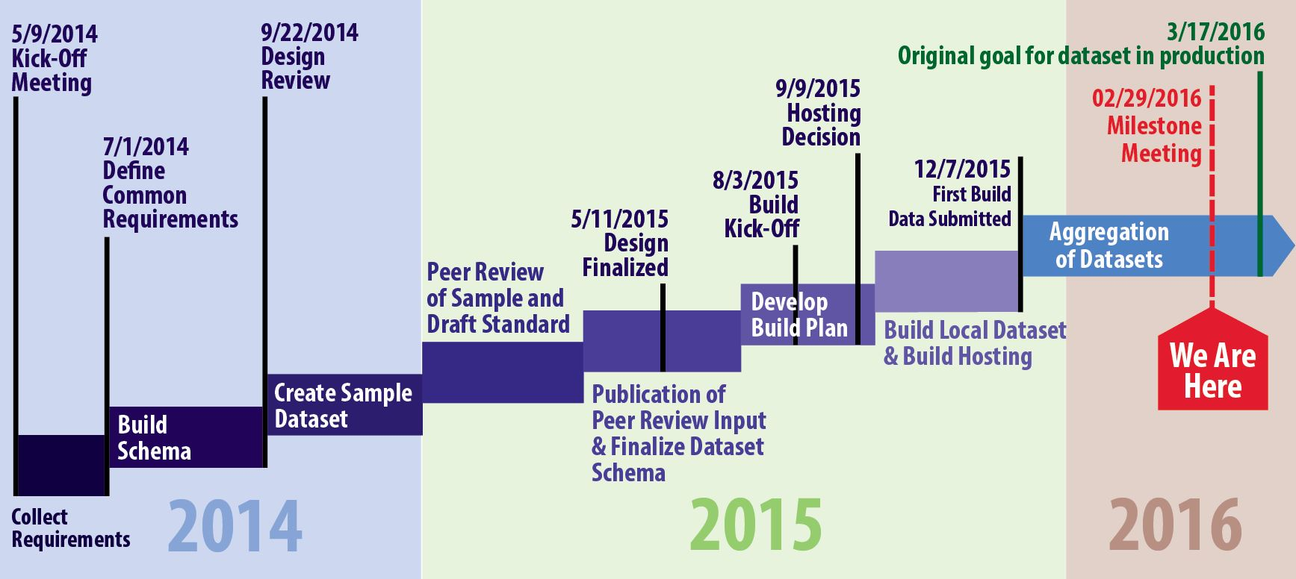**Agenda Item 2) Brief Project Recap and Current Project Timeline**

To date the MRCC project has met *(or very nearly met)* all the timeline milestones for completion of the various first phases of the project *(as identified by the above generalized timeline),* with the submittal of the ‘First Build’ of the data in December 2015, the project enters a new phase (“Second Build”) of the project and need to re-assess the timeline into 2016.

Over the course of the meeting we’ll be working through the items to be more clearly defined, corrected, changed, approved and finished.

In the document, you will see the following symbols used:



The pointer finger indicates the ***main issue*** being described;

The ‘warning’ indicates a ***cautionary note*** about lack of clarity, need for more info or similar issue;

The ‘green light bulb’ indicates a ***friendly reminder or recommendation*** on what to do next or a possible solution to a problem that has been described or revealed;

**Purpose of the Milestone Meeting:**

**Agenda Item 2: Determine if the next phase of the project requires a new charter or is an extension of the existing effort:**

* *Decide if we can amend the existing MRCC Project Charter or draft new one to accommodate the work of the Second Build;*

**Agenda Item 3: Make and approve modifications to the MRCC Local Centerline Standard based on:**

* *What we’ve learned from the First Build process (August – December 2015)*
* *The results of the assessment/audit prepared by Tracy Tisbo at Hennepin County*
* *Clearer understanding of the data needs of the NextGen911 stakeholders*
* *Agree to a list of additional attributes to populate during the ‘Second Build’*

**Agenda Item 4: Determine which Attributes will be populated in the ‘Second Build’**

* *Confirm the approach for a Best Practices Guide resource;*
* *Discuss and document any improvement needed to the edge matching work;*

**Agenda Item 5: Discuss and document the desired frequency of data updates:**

* *Establish a goal/target date for completion of the ‘Second Build’*
* *Short-term goal/target (Need to decide upon frequency of updates)*
* *Long-term goal: a means to facilitate daily updates (Discussion)*

**Agenda Item 6: Confirm the approach to the Best Practices Guide and Edge Matching;**

* *Confirm the approach for a Best Practices Guide resource;*
* *Discuss and document any improvement needed to the edge matching work;*

**Agenda Item 7: Establish and agree to the specific next steps, tasks and goal dates for the ‘Second Build’ phase of the project:**

* *Update and publish MRCC Standard Document and resources;*
* *Perform updates based on the agreed upon revisions to the Standard;*
* *Each county to address the specifics revealed in Tracy Tisbo’s audit;*
* *Population of additional attributes;*
* *Establish goal dates for completion;*
* *Development of a Best Practices Document;*
* *Continued development of the Data Portal by MnGeo;*

**Agenda Item 8: Develop and understanding of the NextGen911 stakeholder community needs;**

**Agenda Item 9: Discuss and offer comment on Ramsey County Position Paper on Discrepancies between the MRCC Road Attributes for Emergency Service Numbers (ESN) and Municipalities and their Polygon Representations;**

**Agenda Item 10: Offer feedback to MnGeo on the development of the Data Portal and understand what steps remain in its development;**

**Agenda Item 3) MRCC Data Standard Revisions**



**MRCC Data Standard “Friendly Reminder”:**

Our road data standard calls for text entries to be **Caps-Lower Case**(not ALLCAPS)

**Element 1.3: Feature Unique ID (UNIQUE_ID)**



**For discussion:**

One proposal was to **change the width from 43 to 45** characters to accommodate a full range of city and county GNIS codes.

Existing example (43 char.): 659507-GM029KH1-476F-B3CA-FF4E9B32A36B (Ramsey County)

Proposed examples (45 char.): 00659507-GM029KH1-476F-B3CA-FF4E9B32A36B (Ramsey County)

02395876-GM029KH1-476F-B3CA-FF4E9B32A36B (City of Shoreview)



Another proposal was to **remove the GNIS prefix altogether** from the **UNIQUE_ID**

**Discussion Points:**

* Review the merits of maintaining the six-digit county GNIS prefix in the UNIQUE_ID field vs. removing it;
* Discuss the potential of the data aggregator (MnGeo) adding the GUID

**Element 2.1: Route System (ROUTE_SYS)**

**Reminder:**

All values to be represented are a **String** (not an integer);

This is done to preserve the leading zero;

1. Interstate
2. US Highway
3. MN Highway
4. County State Aid Highway
5. Municipal State Aid Street

*Etc.*

**Discussion Points:**

* Agree that **ROUTE_SYS** should be a string (not an integer) to preserve the leading zero.

**Element 3.3: Street Pre Type (ST_PRE_TYPE)**



**Two changes proposed:**

Bump column width from **24** to **25**

Expand the domain from the existing **three** values **(Interstate, Highway, County Road**) to **four** values: **Interstate, US Highway, State Highway, County Road);**

**(Recommended) Domain Values for ST_PRE_TYPE**

**Existing values: Proposed values:**

Interstate Interstate

Highway US Highway

County Road State Highway

County Road

**Discussion Points:**

* Do these ***four proposed domain values*** meet the business needs of the stakeholders?

*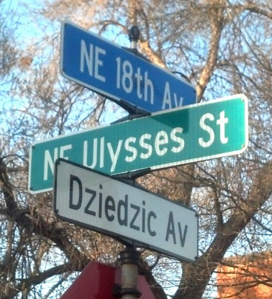***Element 3.9, 3.10 and 3.11: Alternate Street Names 1, 2 and 3**



**Recommendation #1:**

**Alternate 1 and Alternate 2** should contain ***values that are legitimate for generating an MSAG*;**

**Alternate 3** should ***not*** contain names for use in an MSAG.

**This recommendation was advanced by Ramsey County for review, and supported by the NextGen911 stakeholders;**



**Recommendation #2:**

If **Alternate 1** and **Alternate 2** are to contain values legitimate for generating an MSAG, the Next911 stakeholders have indicated they would benefit by having these reclassified from **Optional** to **Conditional**;

**Elements 4.1 through 4.8: Address Ranges**



**Issue:**

Use **Long Integer** for the sake of consistency;

*(Of note: the NENA Standard has a column width of* ***6*** *for address range data, using the* ***Long Integer*** *option frees up the need to assign a width*)

**Discussion Points:**

* Agree to use Long Integer field type for Elements 4.1 through 4.8

**Elements 4.15 & 4.16:**

**Left County Code (COUNTY_L) and Right County Code (COUNTY_R)**



**Issue:** In the First Build, the resulting data for **COUNTY_L** and **COUNTY_R** contained a mix of GNIS Codes, FIPS Codes and text names.

**Results from First Build process:**

**Anoka County GNIS Code Carver County GNIS Code**

**Dakota County GNIS Code Hennepin County GNIS Code**

**Ramsey County FIPS Code Scott County FIPS Code**

**Washington County Text Name**



***This is likely the result of the original MRCC Standard document not providing clear direction to the Build Team, no domains were clearly established in our early draft of the Standard.***

**We have three options:** **NENA Standard** (Name of County, Caps-Lower Case, no suffix)

**FIPS County Code** (Long Integer, 10), or;

**GNIS County Code** (Long Integer, 10)

**NENA Standard Value Name, Caps-Lower Case, No Suffix**

**(String, 50) Anoka County Anoka**

**Carver County Carver**

**Dakota County Dakota**

**Hennepin County Hennepin**

**Ramsey County Ramsey**

**Scott County Scott**

**Washington County Washington**

**FIPS Value FIPS Code**

**(Long Integer, 10) Anoka County 27003**

**Carver County 27019**

**Dakota County 27037**

**Hennepin County 27053**

**Ramsey County 27123**

**Scott County 27139**

**Washington County 27163**

**GNIS Value GNIS Code**

**(Long Integer, 10) Anoka County 659447**

**Carver County 659455**

**Dakota County 659464**

**Hennepin County 659472**

**Ramsey County 659507**

**Scott County 659514**

**Washington County 659526**



*Please refer to the* ***related recommendation*** *on* ***Page 12 (Element 8.6)***

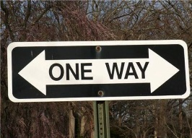**Element 5.3: One Way**



**Issue:**

MRCC Standard and NENA Standard differ in their approach to attributing One Way;

**Value MRCC Standard values: NENA Standard Values:**

Traffic flows from ***to point*** (against arc) **T TF**

Traffic flows from ***from point*** (with the arc) **F FT**

Traffic flows both direction **B B**



***CAD systems such as Tiburon/TriTech require a one character value as is presently being used by the MRCC Standard***

**Description:** The direction of traffic movement along a road in relation to the FROM and TO nodes of the street segment. Which node is **FROM** and which is **TO** are based on the segment’s digitized direction.

**Domain:**  The one-way field has three possible designations:

B – Travel in both directions is allowed

FT – One-way traveling from **FROM** node to **TO** node

TF – One way traveling from **TO** node to **FROM** Node

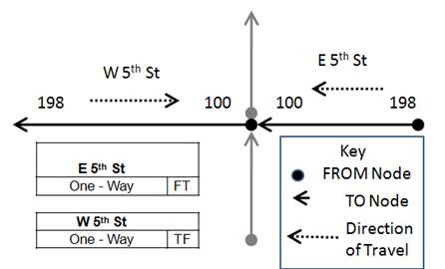

**Example:** *(See graphic at right)*

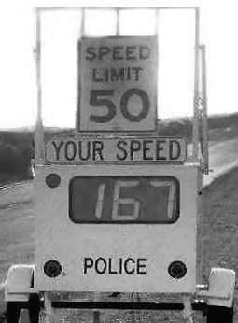**Elements 5.4 & 5.6 Impedance Speed and Speed Limit**



**Clarification:**

Clarify in our documentation that these are **miles per hour** **(MPH)**

**MPH** was assumed; but not formally stated in our documentation.

**Element 6.1 Route Name (ROUTE_NAME)**



**Issue:** In the First Build, the resulting data for **ROUTE_NAME** submitted by the partners contained a mix of syntax. We need a domain to standardize these values.



***This is likely the result of the original MRCC Standard document not providing clear direction to the Build Team.***

**(Suggested) Prefix Values for ROUTE_NAME**

**Value Code**

Interstate **I**



US Highway **USH**

State Highway **STH**

County Road **CR**

County State Aid Highway **CSAH (?)**

**Discussion Points:**

* Do these ***recommended domain values*** meet the business needs of the stakeholders?
* Are there additional values needed to accurately represent the roadways in this context?

**Elements 7.1 & 7.2: Emergency Service Zone (L & R)**



**Issue:**

NextGen911 Stakeholders indicated that using the terminology **Emergency Service Number** for Alias Name (instead of **Emergency Service Zone)** and **ESN** (instead of **ESZ**) is the preferred nomenclature.

**Discussion Points:**

* Discuss changing ‘Zone’ to ‘Number’ and ‘ESZ’ to ‘ESN’ in the MRCC Standard;

**Elements 7.1 - 7.6: Emergency Service Zones, MSAG Communities and PSAP Domains**



**Issue:**

NextGen911 stakeholders are interested in developing **domains** for these values to minimize input errors.

**Discussion Points:**

* Are MRCC participants willing to make use of domains developed by the 911 interests?
* Examples of domains for Emergency Service Zone, MSAG Communities and PSAPs will be presented for consideration on February 29.

**Element 8.2, 8.3 and 8.5: Active Date, Retired Date and Edited Date**



**Issue**

The current MRCC standard has Elements 8.2, 8.3 and 8.5 attribute type as **Date**, however, it **does not specify any *format* for the date data**. At present, NextGen911 stakeholders believe a concise Month/Day/Year (MM/DD/YYYY) format would suffice for their needs.

**Discussion Points:**

* Does the MM/DD/YYYY data format meet the needs of the MRCC group?

Note: The NENA Standard recommends using the ISO 8601 format for storing date and time. (The ISO 8601 format is provided below for reference)



***Recommendation:******MRCC adopts and uses the MM/DD/YYYY format for the foreseeable future and will assess the merits of the ISO 8601 as the need to do so arises.***

**ISO 8601 Date/Time Standard:**

Complete date: YYYY-MM-DD

(e.g. 1970-09-02)

Complete date (hours and minutes): YYYY-MM-DDThh:mmTZD

(e.g. 1970-09-02T18:12+01:00)

Complete date (hours, minutes, sec): YYYY-MM-DDThh:mm:ssTZD

(e.g. 1970-09-02T18:12:30-06:00)

Complete date hours, minutes, sec + decimal fraction of a second:

YYYY-MM-DDThh:mm:ss.sTZD

(e.g. 1970-09-02T18:12:30+07:15-06:00)

Note that the "T" appears literally in the string, to indicate the beginning of the time element;

YYYY: four-digit year

MM: two-digit month (01=January, etc.)

DD: two-digit day of month (01 through 31)

hh: two digits of hour (00 through 23) (am/pm NOT allowed)

mm: two digits of minute (00 through 59)

ss: two digits of second (00 through 59)

s: one or more digits representing a decimal fraction of a second

TZD: time zone designator (Z or +hh:mm or -hh:mm)

**Element 8.4: Edited By (EDITED_BY)**



**Change proposed:**

Change **‘User Name (individual person name)’** to **‘Organization Name’** in the **EDITED_BY** field, not just for the public dataset but for the dataset that is pushed to MnGeo. *(This recommendation arises from Hennepin County’s thorough review of its open data policies and process. Hennepin County will not be publishing their data out to the hosting site using login names or individual’s names)*

The MRCC Data Standard originally was listing individual’s names (the GIS staff member who edited the segment).

**Discussion Points:**

* The merits of removing the personal name of the editor vs. using the County Name;
* Using the County name would potentially be redundant with other data in the dataset;
* The merits using the County department/division instead of just the County;

**EDITED_BY** **values** *(possible example values for a potential domain)*

Carver County GIS

Dakota County GIS

Hennepin County Survey

Hennepin County Public Works

Hennepin County 911 Office

Washington County Survey

*Etc.*

**Element 8.6: Source of Data (SOURCE)**



**Issue:**

In reviewing the First Build dataset, the Counties used a variety of the versions of their names.

In listing their ‘Source’; examples from the ‘First Build’ included the following:

**Anoka County GIS**

**Carver County**

**Dakota County**

**HENNEPIN**

**Ramsey County**

**Scott**

**Washington**



***This is likely the result of the MRCC Standard document not providing clear direction to the Build Team; there was no domain established.***



**Recommendation:**

For Elements 4.15 and 4.16: Use either FIPS or GNIS Code;

For Element 8.6: Use County Names (Caps-Lower Base, No Suffix)

*Develop a domain with the following values:*

Anoka

Carver

Dakota

Hennepin

Ramsey

Scott

Washington

(Etc.)

The domain could potentially include the names of all the counties in Minnesota, plus those of the bordering states of Wisconsin, Iowa, South Dakota and North Dakota, as well as the Canadian provinces of Ontario and Manitoba, with potential for Tribal Name designations as similar unique jurisdictions as the need arises.

**Element 9.1: Functional Class (FUNCTIONAL)**

**<< This can potentially be ‘tabled’ to a later meeting >>**



**Issue:** Functional class was identified as an **optional business element** in the original development of the MRCC data standard. This attribute, is very much desired by MnDOT and the Metropolitan Council for their planning interactions with municipalities and federal reporting requirements. At present, this attribute is being carried in various ways by metro data producers.

A research memo prepared by MetroGIS on November 4, 2015 attempted to provide context and clarity on the differences between the MnDOT/Federal Functional Class and Metropolitan Council/MPO Functional Class. This memo offered a possible solution, to conflate the two into a four-digit ‘marker’ from which any data consuming agency could extract the information they needed.

**Discussion Points:**

* Maintain Functional Class in the MRCC as an ‘optional business element’;
* How are counties, cities and public works departments working with this attribute?
* Review the merits of carrying the two systems (“FUNC_STF” and “FUNC_MPO”) as

two separate attributes;

|  |  |  |  |  |
| --- | --- | --- | --- | --- |
| **FUNC_STF** | ***Description*** |  | **FUNC_MPO** | ***Description*** |
| 1 | *Principal Arterial, Interstate* |  | 100 | *Principal Arterial* |
| 2 | *Principal Arterials, Other Freeway* |  | 211 | *A-Minor, Augmenter* |
| 3 | *Principal Arterial, Other* |  | 212 | *A-Minor, Reliever* |
| 4 | *Minor Arterial* |  | 213 | *A-Minor, Expander* |
| 5 | *Major Collector* |  | 214 | *A-Minor, Connector* |
| 6 | *Minor Collector* |  | 220 | *B-Minor, Arterial* |
| 7 | *Local* |  | 310 | *Major Collector* |
|  |  |  | 320 | *Minor Collector* |
|  |  |  | 999 | *New Road/Under Review* |

* Review the merits of a potential **conflated solution** *(as explored in the November 4, 2016 memo; please refer to the graphic on next page for the conflated solution)*
* Hennepin County has requested an **additional business element** which makes the distinction between ‘urban’ and ‘rural’ *(criteria for determination for this is needed),* does this distinction have value or meet a business need for other data producers/stakeholders?



* ***Do we (the MRCC Core/Build Team) have enough information to make a decision on this***

***If not, what additional information is needed?***

**Element 9.1: Functional Class (FUNCTIONAL) - Continued**

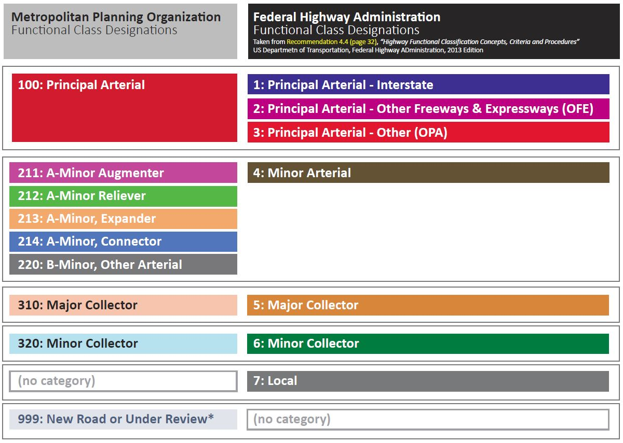Comparing the Federal/State Functional Class attribute with the Metropolitan Council (MPO) attribute indicates they all essentially represent the same data categories

***(See table at right >)***

The Federal/State has more granularity among the Principal Arterials, while the MPO has more granularity among the Minor Arterials.

These two codes could be conflated into a single four digit code that accommodates both systems ***(below):***

**Possible MRCC Code Value**

**1100 Principal Arterial – Interstate**

**2100 Principal Arterial – Other Freeways (OFE)**

**3100 Principal Arterial – Other (OPA)**

**4211 Minor Arterial, A-Minor Augmenter**

*(This could be used for all Minor Arterial designations in Greater Minnesota)*

**4212 Minor Arterial, A-Minor Reliever**

**4213 Minor Arterial, A-Minor Expander**

**4214 Minor-Arterial, A-Minor Connector**

**4220 Minor Arterial, Other Arterial**

**5310 Major Collector**

**6320 Minor Collector**

**7000 Local Road**

**9999 Unclassified/Under Review**

**Element 9.x: Number of Lanes**

**<< This can potentially be ‘tabled’ to a later meeting >>**



**Issue:** Number of Lanes attribute was not listed as part of the original scope for the MRCC project, however as the MRCC project has gained visibility, numerous stakeholders *(notably traffic and transportation modelers)* have indicated that this attribute is extremely valuable and very vital to the work they do.

Conversations with several modelers have indicated that ***simply the number of through lanes on a given* segment** would adequately meet the majority of their modeling needs.

**Discussion Points:**

* Cities, counties and MnDOT are the (assumed) authoritative source for this attribute;
* Do cities or counties have a business need for this attribute?
* Level of effort for just the through-lanes appears to be much less effort than trying to accommodate number of lanes for sub-segment portions (turn lanes, center-turn lanes, etc.)

Just the number of through lanes could be carried as an attribute on a segment, but for the full detail of the number of lanes, an event in a linear reference system is preferred;

**Possible Decision/Direction:**

* Maintain ‘Number of Lanes’ in the MRCC as an ‘optional business element’ which can be voluntarily populated by data producers. This attribute is to be addressed and potentially attributed in the future after more pressing issues are resolved;
* MRCC/MetroGIS to potentially perform a small ‘pilot project’ or ‘test area’ as part of the ‘Second Build’ to gather number of lanes attributes for testing and review by the modeler stakeholders;

**Element 9.y: Urban v. Rural**

**<< This can potentially be ‘tabled’ to a later meeting >>**



**Issue:** This would be an *optional* business element that is not part of the existing standard.

Hennepin County in its internal review determined that this would be a useful attribute to consider including.

**Discussion Points:**

* Do any of the other metro counties have a business need for the distinction between ‘urban’ and ‘rural’;
* What are the determination criteria for categorizing a road as ‘urban’ vs. ‘rural’?



**Recommendation:**

***Element 9.1 (Functional Class) and 9.x/9.y (Number of Lanes and Urban v. Rural) could be addressed as part of a future pilot study/proof of concept in a small sample area of the metro region once more progress is made on the core attributes of the MRCC.***

**Agenda Item 4) Attributes to be populated during the “Second Build”**



**Issue:** For the ‘First Build’, the partners identified a number of core MRCC attributes to populate, these are listed in the ‘Populated for 1st’ column on the tables on this and the following pages. We will determine which attributes will be populated during the ‘Second Build’ period.

**Elements 1, 2 and 3:**

|  |  |  |  |  |  |
| --- | --- | --- | --- | --- | --- |
| **Element** | **ID** | **Alias** | **Database** | **Populated for 1st** | **Populated for 2nd** |
| **1** | 1.1 | Object ID | OBJECT_ID | **Yes** | **Yes** |
| **Identification** | 1.2 | Route ID | ROUTE_ID | No |  |
|  | 1.3 | Feature Unique ID | UNIQUE_ID | **Yes** | **Yes** |
| **2** | 2.1 | Route System | ROUTE_SYS | **Yes** | **Yes** |
| **Linear** | 2.2 | Route Direction | ROUTE_DIR | No |  |
| **Reference** | 2.3 | Directional Route ID | DIR_RTE_ID | No |  |
|  | 2.4 | Local to State | LOC_STATE | No |  |
|  | 2.5 | Primary Status | PRIME_STAT | No |  |
| **3** | 3.1 | Street Pre Modifier | ST_PRE_MOD | **Yes** | **Yes** |
| **Geocoding** | 3.2 | Street Pre Directional | ST_PRE_DIR | **Yes** | **Yes** |
|  | 3.3 | Street Pre Type | ST_PRE_TYP | **Yes** | **Yes** |
|  | 3.4 | Street Name | ST_NAME | **Yes** | **Yes** |
|  | 3.5 | Street Post Type | ST_POS_TYP | **Yes** | **Yes** |
|  | 3.6 | Street Post Directional | ST_POS_DIR | **Yes** | **Yes** |
|  | 3.7 | Street Post Modifier | ST_POS_MOD | **Yes** | **Yes** |
|  | 3.8 | Street Name Full | ST_CONCAT | **Yes** | **Yes** |
|  | 3.9 | Alternate Street Name1 | ST_NAME_A1 | No |  |
|  | 3.10 | Alternate Street Name2 | ST_NAME_A2 | No |  |
|  | 3.11 | Alternate Street Name3 | ST_NAME_A3 | No |  |

**Elements 4 and 5:**

|  |  |  |  |  |  |
| --- | --- | --- | --- | --- | --- |
| **Element** | **ID** | **Alias** | **Database** | **Populated for 1st** | **Populated for 2nd** |
| **4** | 4.1 | Left From Address | ADR_FR_L | ***4.1-4.4 (or) 4.5-4.8*** | ***4.1-4.4 (or) 4.5-4.8*** |
| **Geocoding** | 4.2 | Left To Address | ADR_TO_L | ***4.1-4.4 (or) 4.5-4.8*** | ***4.1-4.4 (or) 4.5-4.8*** |
| **Side** | 4.3 | Right From Address | ADR_FR_R | ***4.1-4.4 (or) 4.5-4.8*** | ***4.1-4.4 (or) 4.5-4.8*** |
|  | 4.4 | Right To Address | ADR_TO_R | ***4.1-4.4 (or) 4.5-4.8*** | ***4.1-4.4 (or) 4.5-4.8*** |
| **Theoretical** | 4.5 | Theor. Left From Addr. | T_ADR_FR_L | ***4.1-4.4 (or) 4.5-4.8*** | ***4.1-4.4 (or) 4.5-4.8*** |
| **Ranges** | 4.6 | Theor. Left To Addr. | T_ADR_TO_L | ***4.1-4.4 (or) 4.5-4.8*** | ***4.1-4.4 (or) 4.5-4.8*** |
|  | 4.7 | Theor. Right From Addr. | T_ADR_FR_R | ***4.1-4.4 (or) 4.5-4.8*** | ***4.1-4.4 (or) 4.5-4.8*** |
|  | 4.8 | Theor. Right To Addr. | T_ADR_TO_R | ***4.1-4.4 (or) 4.5-4.8*** | ***4.1-4.4 (or) 4.5-4.8*** |
|  | 4.9 | Left Zip Code | ZIP_L | **Yes** | **Yes** |
|  | 4.10 | Right Zip Code | ZIP_R | **Yes** | **Yes** |
|  | 4.11 | Left City ID | CITYID_L | **Yes** | **Yes** |
|  | 4.12 | Right City ID | CITYID_R | **Yes** | **Yes** |
|  | 4.13 | Left City Name | CITY_L | **Yes** | **Yes** |
|  | 4.14 | Right City Name | CITY_R | **Yes** | **Yes** |
|  | 4.15 | Left County Code | COUNTY_L | **Yes** | **Yes** |
|  | 4.16 | Right County Code | COUNTY_R | **Yes** | **Yes** |
|  | 4.17 | Left State | STATE_L | **Yes** | **Yes** |
|  | 4.18 | Right State | STATE_R | **Yes** | **Yes** |
|  | 4.19 | Left Parity | PARITY_L | No |  |
|  | 4.20 | Right Parity | PARITY_R | No |  |
| **5** | 5.1 | Elevation From | ELEV_FROM | No |  |
| **Routing** | 5.2 | Elevation To | ELEV_TO | No |  |
|  | 5.3 | One Way | ONEWAY | No |  |
|  | 5.4 | Impedance Speed | SPEED_IMP | No |  |
|  | 5.5 | Emergency Access | EMERG_ACC | No |  |
|  | 5.6 | Speed Limit | SPEEDLIMIT | No |  |

**Elements 6, 7, 8 and 9:**

|  |  |  |  |  |  |
| --- | --- | --- | --- | --- | --- |
| **Element** | **ID** | **Alias** | **Database** | **Populated for 1st** | **Populated for 2nd** |
| **6** | 6.1 | Route Name | ROUTE_NAME | **Yes** | **Yes** |
| **Cartography** | 6.2 | Route Number | ROUTE_NUM | **Yes** | **Yes** |
| **7** | 7.1 | Left Emg Service Zone | ESZ_L | No |  |
| **Enhanced 911** | 7.2 | Right Emg Service Zone | ESZ_R | No |  |
| **NextGen 911** | 7.3 | Left MSAG Community | MSAG_C_L | **Yes** | **Yes** |
|  | 7.4 | Right MSAG Community | MSAG_C_R | **Yes** | **Yes** |
|  | 7.5 | Left PSAP | PSAP_L | No |  |
|  | 7.6 | Right PSAP | PSAP_R | No |  |
| **8** | 8.1 | Status | STATUS | No |  |
| **Maintenance** | 8.2 | Active Date | ACT_DATE | No |  |
|  | 8.3 | Retired Date | RET_DATE | No |  |
|  | 8.4 | Edited By | EDITED_BY | No |  |
|  | 8.5 | Edited Date | EDITED_DT | No |  |
|  | 8.6 | Source of Data | SOURCE | **Yes** | **Yes** |
| **9** | 9.1 | Functional Class | FUNCTIONAL | No |  |
| **Business** | 9.2 | Surface Type | SURF_TYPE | No |  |

**Agenda Item 5) Frequency of Road Centerline Data Updates**



**Issue:** During the development of MRCC, there have been numerous discussions and statements made about the assumed, desired and potential frequency of road data updates. This agenda item is intended to provide a dedicated portion of the meeting to formally discuss, understand and document the group’s thoughts, ideas and desires for road data updates.

The emergency response stakeholders and others have indicated that they desire frequent—preferably daily—updates to the data. Other stakeholders feel that weekly, monthly or quarterly data updates are sufficient to meet their needs.

The data producers are encouraged to relate and describe what is possible in the present, near future and the long term given their available resources.

**Discussion Points:**

* What is the agreed upon/desired frequency of updates for the near term? (next 6 months)
* Mid-term? (next 12 months)
* Long-term? (12 months and beyond)

**Agenda Item 6) Best Practices Document and Edge Matching Process**



**Item 6a) Best Practices Document:** Given the amount of work that has gone into developing the MRCC data standard and First Build of the MRCC dataset; there is a need to capture, document and communicate what has been learned for future use and to assist new partners wishing to build upon the MRCC’s work.

**What is the purpose of an MRCC Best Practices Document?**

The MRCC Best Practices Document would serve two main purposes:

* To record what has been learned in the development of the MRCC standard;
* Provide a reference and guidance to staff and to partners in Greater Minnesota counties in using the standard;

**Who would use this document?**

Anyone creating, developing or editing road centerline data using the MRCC standard. This would include GIS professionals at the city or county level in the metro and other participants in Greater Minnesota

**Who would assume responsibility for updating, editing and publishing the document?**

Geoff Maas (MetroGIS Coordinator) has volunteered to be the ‘steward’ of the Best Practices Document with the approval of the MRCC team for the duration of the project and beyond as needed. He would work with County ‘Build Team’ staff to collect existing relevant material and prepare the first draft, maintain the subsequent drafts and conduct edits on its content at the direction of the Counties.



***County technical staff and management would have the final say as to the content, editorial review and approval of the final published document.*** County technical staff would direct the method by which changes and edits are approved and included and the schedule by which new versions are published. The most current version would be consistently available on the MRCC project website page *(or comparable project webpage)* to the public and geospatial community.

**Discussion Points**

* Document would include best practices for specific issues such as consistent treatment of frontage roads, edge matching, address range conflicts, and so on as needed and dictated by the data producers
* Is this approach agreeable to the group?
* If so, communication and development of this can begin this spring/summer to begin to develop the document;
* If not, please indicate what solution(s) would be more amenable or useful;

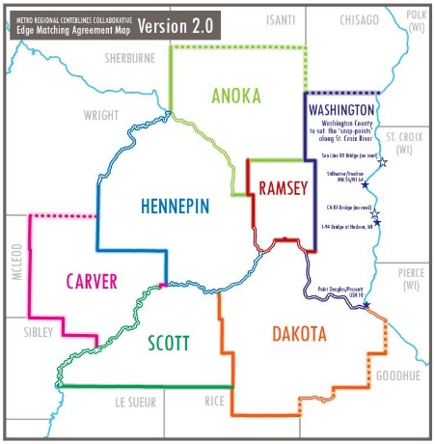**Item 6b ) Edge Matching Process.** During the First Build, the Seven Metro Counties agreed to try and test a method where they would snap their roads to those of their northern and eastern neighbor county, and, in turn, their southern and western neighbors would snap to them. As edge matching is a vital feature for an inter-jurisdictionally functioning dataset, documenting a consistent process for doing this should be included in the Best Practices Document.

**Points of Discussion:**

* Did the ***“control west + south/cede north and east”*** work as planned during the First Build process?
* Does this approach have to be slightly modified, radically changed or scrapped all together?
* How can the edge-matching process be improved?



* Is there value in having each county designate a specific GIS staff person as their ***“border point ‘czarina’ or ‘czar’”*** to act as the point-of-contact for documenting and handing tricky boundary issues?
* Method and practice on how this is done will be fully documented, described and illustrated in the forthcoming MRCC Best Practices Document;

**Additional Rules/Guidelines:**

* Counties need only load the segments that *they are the source for* along the boundaries;
* Work toward the elimination of overlaps *(as much as possible and feasible)* along boundaries;
* Ensure address range data of border roads are correct and verified by both sides of the boundary;

**Agenda Item 7) Project Next Steps and Timeline Adjustments**

We have two initial ‘sets of tasks’ for continued work: the first relates to the data standard and the dataset, the second group to the tasks around aggregation and validation and the third group to further stakeholder review and advancing the dataset to the state level.

**Task Set 1: MRCC Data Standard and Dataset**

**1.1 Modification, editing and improvement of the MRCC Data Standard based on the discussion and decisions of the February 29, 2016 Milestone Meeting:**

Who: MetroGIS (Maas, et. al.)

When: This begins **immediately** after the meeting; the MRCC standard document will be modified as per the recommendations, edits and approvals of the group and published for use from the project website on metrogis.org ASAP; edits and updates to be complete and published no later than **Friday, March 4, 2016;**

What: Editing and update of the data standard document;

Publication of updates standard on the project website;

Electronic circulation of revised document for MRCC team approval;

Continued collection/documentation of any/all additional recommendations from the MRCC members regarding the standard document;

**1.2 ‘Second Build’ Effort**

Who: Metro County Staff Members (Build Team Members);

When: (Date to be agreed upon by the Core/Build Team members) **_______ ___, 2016**

What: Modify data to fit the revised standard (as per the revisions of Feb 29, 2016) and:

Correct the data as per Tracy Tisbo’s review;

Population of additional attributes;

Internal aggregation

**1.3 Update all project materials and publications (other than the Standard)**

Who: MetroGIS (Maas, et. al.)

When: Complete by **Friday, March 12, 2016**

What Update all MRCC project materials and publications to reflect new info and schedule as decided upon in the Milestone Meeting;

**Task Set 2: Aggregation, Validation and Publication**

**2.1 Goal Date for Publication and Public Availability of MRCC Dataset**

Who: MRCC Core and Build Teams and MnGeo Staff

When: (Date to be agreed upon by the Core/Build Team members) **_______ ___, 2016**

What: Set a goal date on which the first published version of the MRCC Dataset will be available to the data consuming public from the Geospatial Commons;

**2.2 Refinements and improvement to the aggregation, validation and publication process**

Who: Data publishers and MnGeo staff continued developing the aggregation portal

When: **(on going, goal dates to be determined)**

What: Develop scripts for internal (County) and external (State/Aggregator) validation

***(Additional next steps/tasks will be added***

***during the course of the Milestone Meeting)***

**Agenda Item 8) NextGen911 Integration**

A presentation by Adam Iten about how MRCC Centerline Dataset will be used and integrated to meet the needs of the NextGen911 stakeholders;

A packet of NextGen 911 materials and resources will be sent out on **Monday, February 22** for the review of the MRCC Project Team members.

NextGen911 stakeholders will be on hand to field questions from the MRCC Project Team

**Agenda Item 9) County Position Paper on Topology**

Ramsey County’s GIS Manager Matt Koukol has prepared a ‘position paper’ on discrepancies between the MRCC road attributes for emergency service numbers (ESN) and municipalities and their polygons.

We are allotting some time in this meeting for a discussion and reaction to this approach and the implications it has for the MRCC project and the needs of the NextGen911 stakeholders.

The paper is published in full in Appendix A of this document, beginning on **page 28.**

**Agenda Item 10) MnGeo Hosting Tool Demonstration and Discussion**

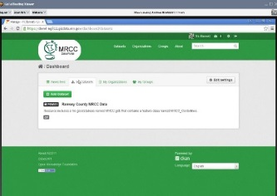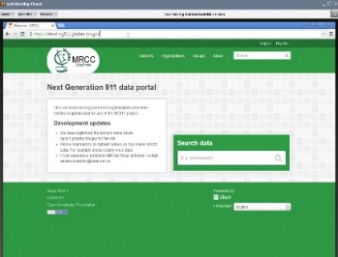**Context:** The MRCC project members agreed that MnGeo would be the organization to aggregate and host the dataset. MnGeo is currently developing an interface for data producers to submit their MRCC data; working in tandem with their NextGen911 data portal effort. Ali Wieckowicz and Andrew Koebrick from will be on hand to demonstrate the interface, field questions and gather feedback on the data portal in development, they will discuss:

* Progress on the portal and process to date;
* 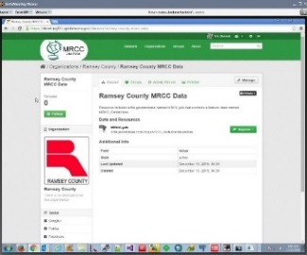Review of the requirements;
  + Data Portal;
  + Data Validation and Aggregation;
  + Data Repository;
* A closer look at the front-end of the portal (demonstration);
* Update on the status of remaining functionality requirements;

Ali and Andrew will field questions from the group, and ask that county partners be prepared to provide answers and insights on the following questions from MnGeo.

**Questions for the County Partners from MnGeo regarding the Portal and Validation:**

***Validation and Transformation.***

***Are there any thoughts on validation/transformation processes that will logically need to be performed within the MRCC Hosting Repository?***  The metro partner counties have indicated that they will be responsible for ensuring their data has been internally validated and meets the needs of the regional centerline dataset use cases as illustrated in the *MRCC County Boundary Edge Matching Guide*. ***Are there validation or transformation processes that make sense to be performed against the regional dataset or during aggregation?***

***Notifications of Success/Failure with Validation.***

***Are there any specific use cases or business processes that involve notifications, for example, regarding validation success/failure?  Are there any thoughts regarding the id/role management functionality within the portal as it relates to MRCC Centerlines or NG911 data?*** The original requirements for MRCC Hosting identified the need for notifications about the status of data updates.  The portal technology that is currently being evaluated for the hosting solution has an identity management model that is very flexible and can be leveraged to support groups/organizations/roles for fine grained authorization or targeted notifications.

***Use of the Portal beyond its application to the MRCC***

***Are there other projects/processes where the current process of ‘local data delivered to state agencies’ could be improved by implementing the same portal technology demonstrated for the MRCC Host/NG911 Portal?*** Clearly there is significant potential to consolidate current processes and modes used by local data authorities to provide MnGeo and other state agencies data updates for data that may not be appropriate for general publication or the Geospatial Commons.

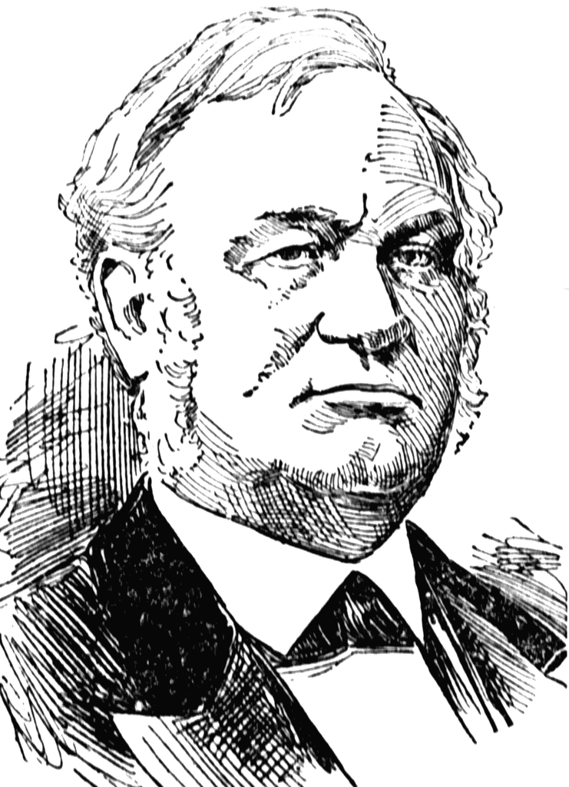

**Appendix A:**

**Ramsey County Position on Discrepancies between the**

**MRCC Road Attributes for Emergency Service Numbers (ESN) and Municipalities and their Polygon Representations**

***Alexander Ramsey***

***(1815-1903)***

**EXECUTIVE SUMMARY**

Ramsey County recognizes that there may be discrepancies between the value for an ESN or Municipality at a given point along a road segment when the boundary is roughly equivalent to a roadway.

Ramsey County believes that these discrepancies do not degrade the quality or timeliness of emergency response, reduce locational accuracy of the data, or limit the capabilities or effectiveness of any functioning system. Correcting these discrepancies would result in one or more of the following:

* Consumption of resources from the County that could better be spent improving our data in ways that will improve quality of emergency response (such as collecting and improving address and landmark data)
* Increased overhead of maintenance of roadway data by increasing feature counts, which may decrease system performance
* Creation of polygons that do not reflect the best interpretations of established boundaries
* Alterations of roadway representations in such a way as to degrade their use for other county needs of higher value, such as routing or mapping.

For these reasons, Ramsey County will not be adjusting ESNs, municipal boundaries, or roadway data based solely on discrepancies between these items.

**DISCUSSION**

Emergency Service Numbers (ESN) are identifiers attached to telephone numbers by telephone companies and used by them to link to specific responder information to an emergency call. The only use these to a county would be if their Public Safety Answering Point (PSAP) does not have a Computer Aided Dispatch System (CAD). In a county with a CAD, the CAD converts this information into the appropriate response agencies. The area in which telephone numbers have the same ESN can be represented as a polygon, called an Emergency Service Zone (ESZ).

In Ramsey County, the CAD does not rely on any polygon information or ESN data for the assigning of service providers to a call. Instead, all of the information is attributed to the road centerlines based on the location of the call. Ramsey County has spent considerable time and effort to accurately attribute this information, and proper maintenance of this information is a high priority. Polygonal representations of Municipalities are used merely as backdrops for mapping images, and serve no greater functional purpose.

For the vast majority of the road network which falls inside of a single ESZ or municipality, there should be no discrepancy between the assign values on the road and the appropriate polygon. However, when ESZ’s or municipal borders are roughly coincident with a road, there are possibilities for discrepancies based on several issues:

1. The road representation may be a digitization based on pavement or center of road right of way while the municipal boundary may be based on other factors such as cadastral records and surveys.
2. Agreements for coverage among responders may not match exactly match the surveyed or otherwise agreed upon boundaries for municipal jurisdictions.
3. Divided roads can generate road segments in a road system required for connectivity of the network but which logically do not follow the attribution of their polygons in which they fall.

**EXAMPLE OF CONFLICTING CONDITIONS**

Examples of these issue may be seen in the image below:

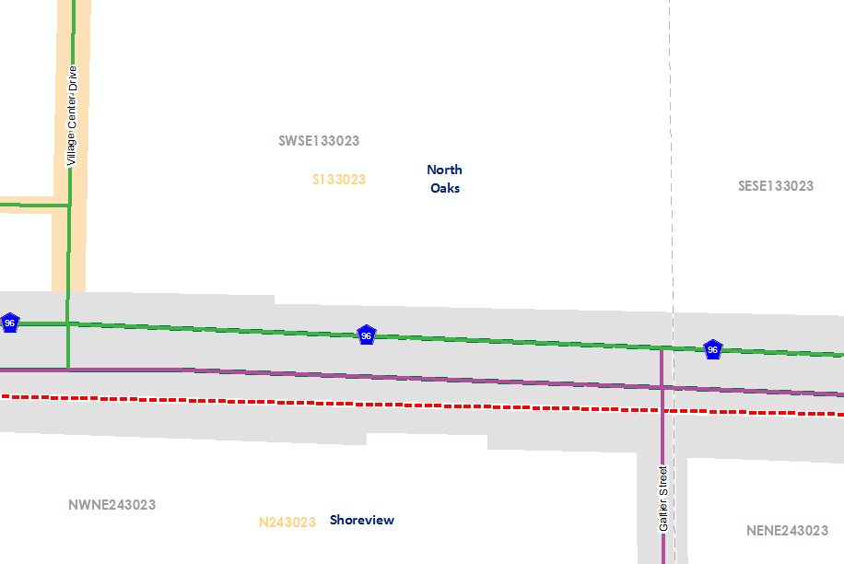

MUNICIPAL BOUNDARY (dashed red line): The boundary between North Oaks and Shoreview is set at the Public Land Survey boundary between sections 13 and 24 if Township 3023. This is the appropriate location for this boundary.

ROAD REPRESENTATION: Common understanding is that the highway represents the boundary of the communities. The grey area in the image represents the Right of Way for the road, and it can be seen that the boundary does fall within this area. However, the specific road representations for this stretch of Highway 96 were created based on high accuracy imagery and follow the approximate centerline of the divided road carriageways. This results in all of the Highway 96 road features in this area as falling entirely within the North Oaks polygon. Despite this, we maintain attribution on the roads that indicates that the east-bound lanes are in Shoreview, to match common understanding.

Further issues with removing any discrepancies between the various polygons and the road network are revealed when considering the small portions of Village Center Drive and Galtier Street which are required in the road network to link the opposing carriageways. No part of Village Center Drive exists in Shoreview nor does any part of Galtier exist in North Oaks. However any change that harmonizes the road network with the municipal boundaries would either violate these facts or require a municipal boundary that is clearly distorted to meet this goal, and therefore questionable for other purposes.

Emergency Service Zones: In the case above, Shoreview and North Oaks are both in the same ESZ; however, this could change at some point. In addition, one can image other municipal boundaries where similar situations exist, yet they do not share the same ESZ. In these cases, it one could clearly image where responders divide this road based on the common understanding of the boundary with the east-bound lanes being served by the southern responders and the west-bound lanes being served by the northern responders. Attempting to harmonize this situation would result in the same issues as attempting to match the municipal boundaries.

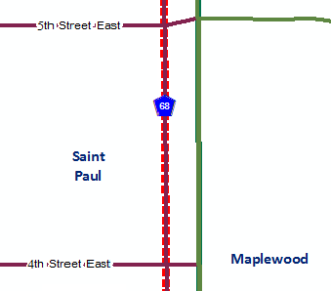**A MORE COMMON EXAMPLE**

The image at right illustrates a more common example of this type of issue. The municipal boundary between Saint Paul and Maplewood has been established as the south-bound lane of County Highway 68, which is co-incident with the survey boundary between Sections 35 and 36 of Township 2922. In this case, the ESZ would have the same boundary. The extensions of the 4th and 5th Streets to connect with the north-bound lane are required to enter into Maplewood. However, there is no response from Maplewood on either of these streets, nor should they be considered in Maplewood as part of a street inventory. The solution is to code the ESZ and City values for the streets as Saint Paul, despite their existence in Maplewood.

**LIMITED VALUE OF ESZ DATA TO COUNTIES**

ESZ are largely useless for most counties. The use they may have in cases where an emergency call needs to go to another PSAP is very limited, especially as municipal information can be substituted in nearly all cases. Due to this, creation and maintenance of an ESZ polygon requires the county to dedicate resources to a pursuit for which they have no business need. These resources should be used in efforts that will improve our emergency services. Ramsey County has no problem providing “generalized” which correspond to the appropriate municipal boundaries, but creating ESZ’s that “match” the street data is not an activity with any value to the county, nor is it entirely clear how it would be done, based on the issues above.

**PERCIEVED NEED FOR RECONCILING DIFFERENCES**

Given the difficulties with reconciling the representations of the roads with the actual conditions in the field, it is important to understand the business needs behind requests for this reconciliation. Ramsey County is aware of four potential drivers for this reconciliation and would like to address each in turn.

1. *Belief that discrepancies will result in confusion in assigning emergency response resources*: How any particular CAD system dispatches units for response is based on the architecture of that system. Each system also has highly specific requirements and configurations for GIS data for it to be used. As such GIS features produced for other functions, even similar functions such as NG-911 call routing, are unlikely to be consumed by the CAD system. Ramsey County has put in considerable effort to ensure that the emergency response system works appropriate with the data we supply it, and this will continue to be of primary importance to the county. Any discrepancies currently in our data do not result in any confusion or degradation of service – in fact, perceived discrepancies may actually be required for desired functionality.
2. *Belief that discrepancies will degrade call routing capacity of NG911*: The exact means by which NG-911 call routing will be accomplished is a vendor specific function. However, we are confident that the areas were discrepancies are identified are such that they will not significantly impact any geolocation process. Many discrepancies will fall on road segments without address values, so they are not options for geocoding call locations based on addresses. If a call is being geocoded based on an X/Y location, Ramsey County believes that there are other issues that may result in just as great an error as would be represented by these discrepancies. For instance, cell phone calls are currently assigned to a PSAP based on the location of the cell tower. This inaccuracy dwarfs the issues of these discrepancies. Even if a GPS location is used based on the phones location, it is likely the inaccuracy of the GPS measurement is greater than the distance of most of these discrepancies. Clear articulation of the methods for geocoding calls for routing and improvements in mobile cell GPS accuracy would be two reasons for a re-evaluation of this position.
3. *Belief that discrepancies will result in confusion regarding steward or owner of core data*: All data elements should be identified with ownership information independent of their spatial location. Agreements between local jurisdictions regarding the submission of these features to common datasets may result in differences between the presumed and actual steward or owner. While the existence of some “master” geometry that defines ownership/stewardship for all elements inside of it would be a very simple solution, Ramsey County does not feel that a single polygon could be developed for all required features, and that querying individual features as needed is a better solution.
4. *Discrepancies will be flagged in any automated processes which compare values on road data related to the polygons in which they fall:* Ramsey County agrees that this issue would be unavoidable with the discrepancies in the system. However, we have no business case for which this generates any significant issues. The generation of these discrepancies as part of a QC check of the data would be helpful and it would take someone to review the list of errors to determine if any of them are actual issues that need to be addressed. This is no different than many of the automated queries we run on systems now which return a set of flagged items, some of which may be actual errors but many others are not.

**CONCLUSION**

Given that the types of discrepancies noted in this document do not have clear solutions, may be unavoidable to maintain valid data in other ways, and present no clear issues for any business cases at the County, or we believe, in the larger community, we will not be making any concerted effort to eliminate these items from our data sets. Where they can be addressed during the course of our regular editing without doing a disservice to our data for other uses, they will likely be addressed.